LAB NO: 6

LAB AIM: To implement the Perceptron Learning Algorithm.

DATASET AND RESOURCES : seeds_new dataset from classroom and Python/Jupyter Notebook

DATE OF PERFORMANCE:09 - 10 -2026

GITHUB REPO LINK :
https://github.com/Prabhkirat-Singh-Marwah/ML-PRACTICALS/tree/main/Practical-06

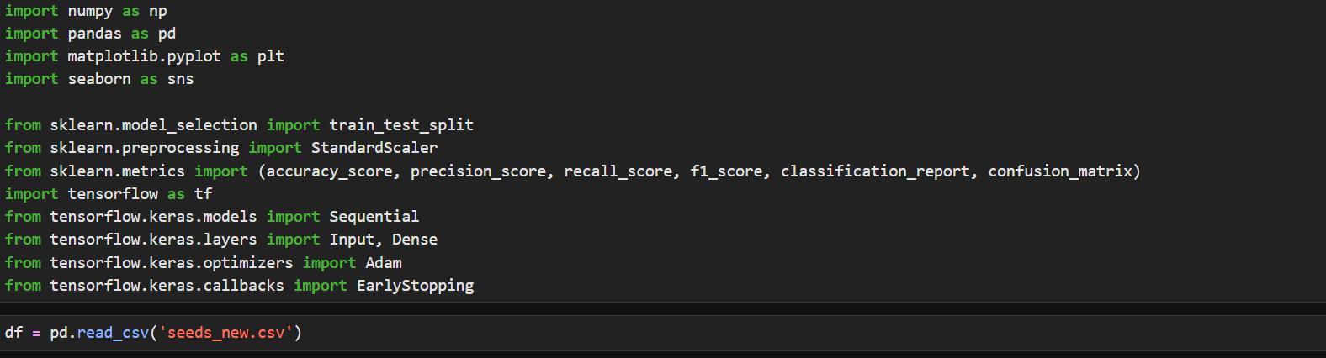This command imports all essential libraries needed for us to process the dataset and run out code .

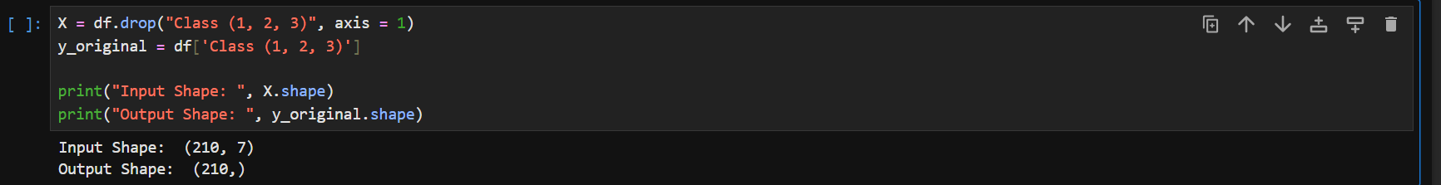
X has all the feature columns that will act as input for us and y hold output columns , this command prints these columns.
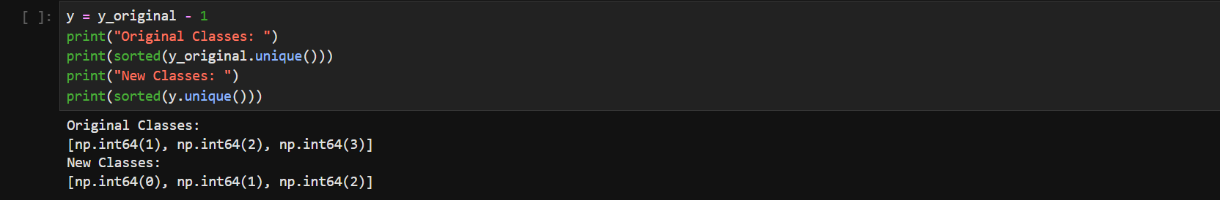
Keras expects class labels to start from 0, so we subtract 1 from every label.
The prints confirm the change from [1, 2, 3] to [0, 1, 2]
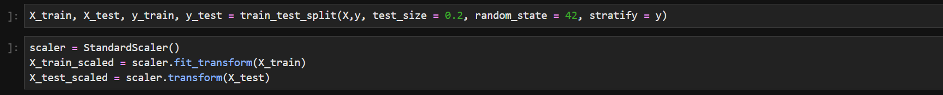
This command divides the split of training and testing data of the dataset for our model, the model is usually trained on 80% data and 20% is left for training it .

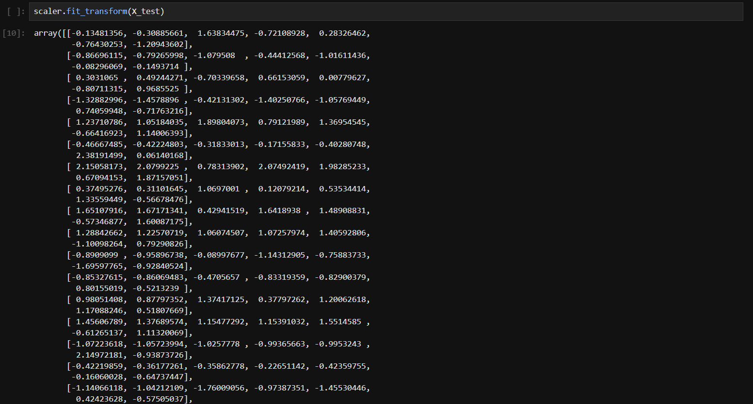
This command Is used to make all data values in same range so no value dominates others , this is used when data has large value differences so normalization is done.
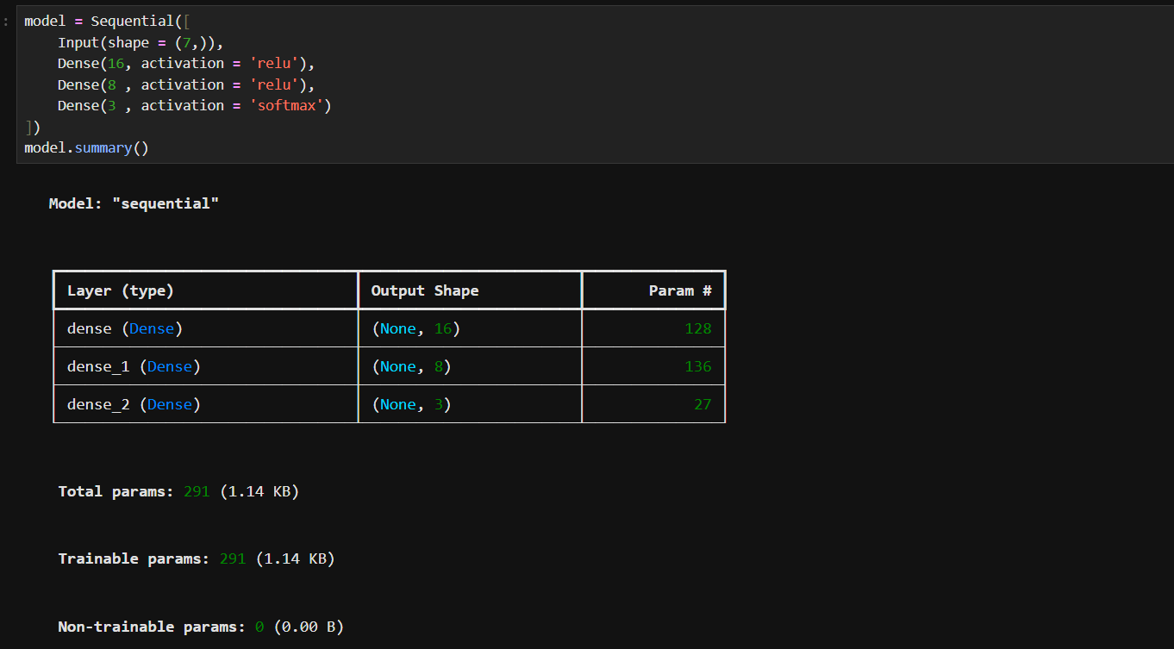
The network takes 7 inputs, passes them through a layer of 16 neurons, then 8 neurons, and ends with 3 outputs (one per class).

this command tell how the model will learn, the loss measures how wrong the predictions are, and accuracy is tracked while training.

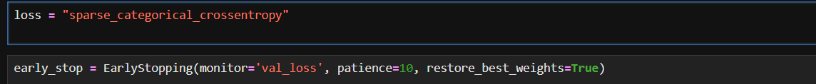
This just stores the loss name in a variable.
This stops training automatically if the validation loss doesn’t improve for 10 rounds.
It also restores the best version of the model, which helps prevent overfitting.
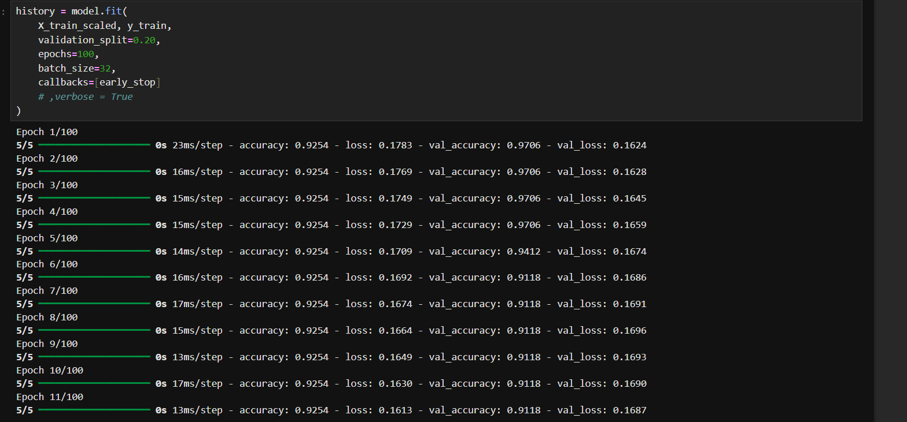
This command basically trains the model on the 80% of the dataset provided as training data .

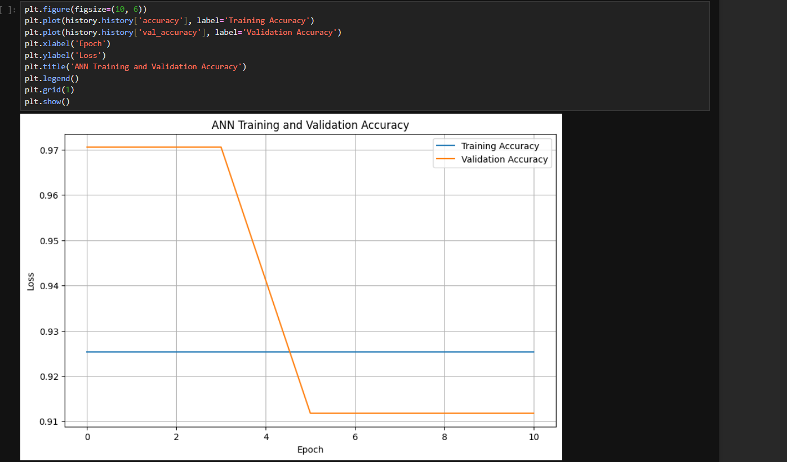
This draws a graph of how accuracy improved over each epoch for training and validation data.

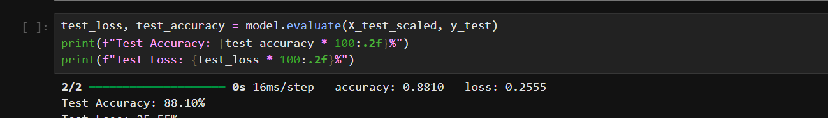
This checks the model on data it has never seen and prints the final accuracy and loss.
Multiplying by 100 and using .2f shows the numbers as percentages with 2 decimals.

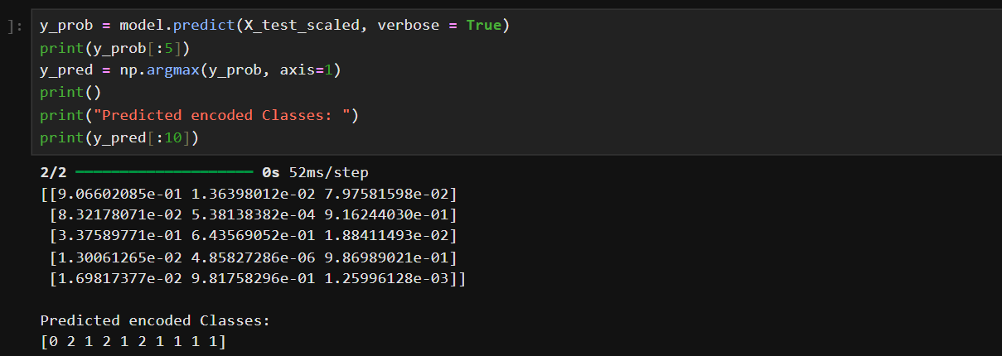 predict gives 3 probabilities for each test sample, and argmax picks the class with the highest probability.
The prints show the first few probabilities and predicted classes (0, 1 or 2).

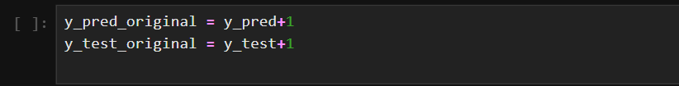
We had earlier changed the index to start one value earlier, so now we reverse it so the current value prints data that matches the columns of original dataset

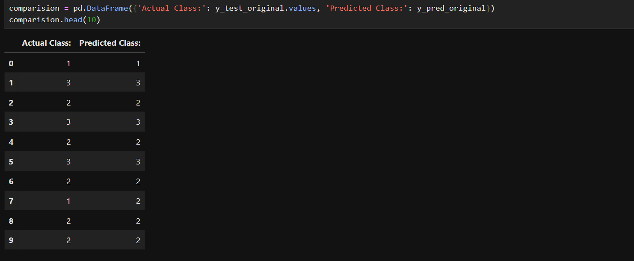
This builds a small table with the real class next to the predicted class.
It lets us see how many of the first 10 predictions are correct.

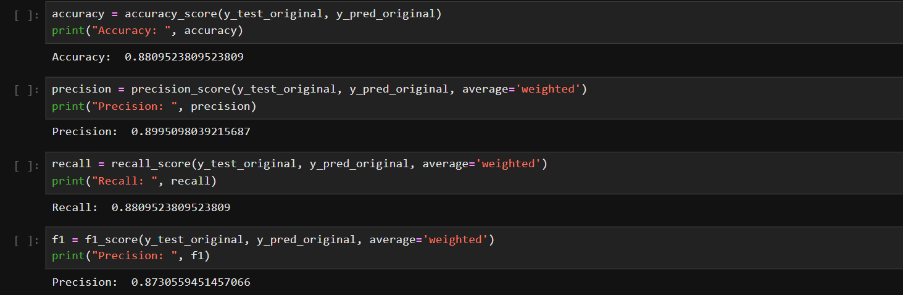these commands print the values like precision recall f1 score for our model to check how well our model is predicting and if its overfit or underfit.

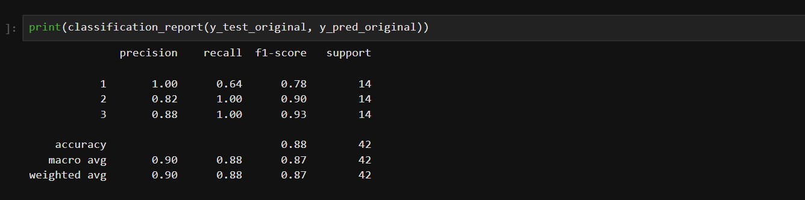
Thid command prints metrics like f1 score accuracy precision and recall for each individual class to compare more precisely which class has best prediction.

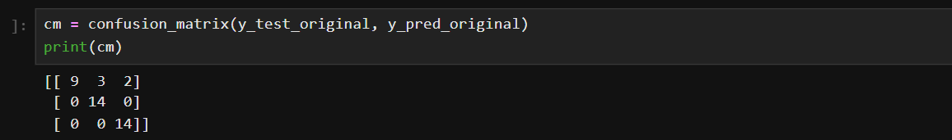
This command prints the confusion matrix for our dataset and model

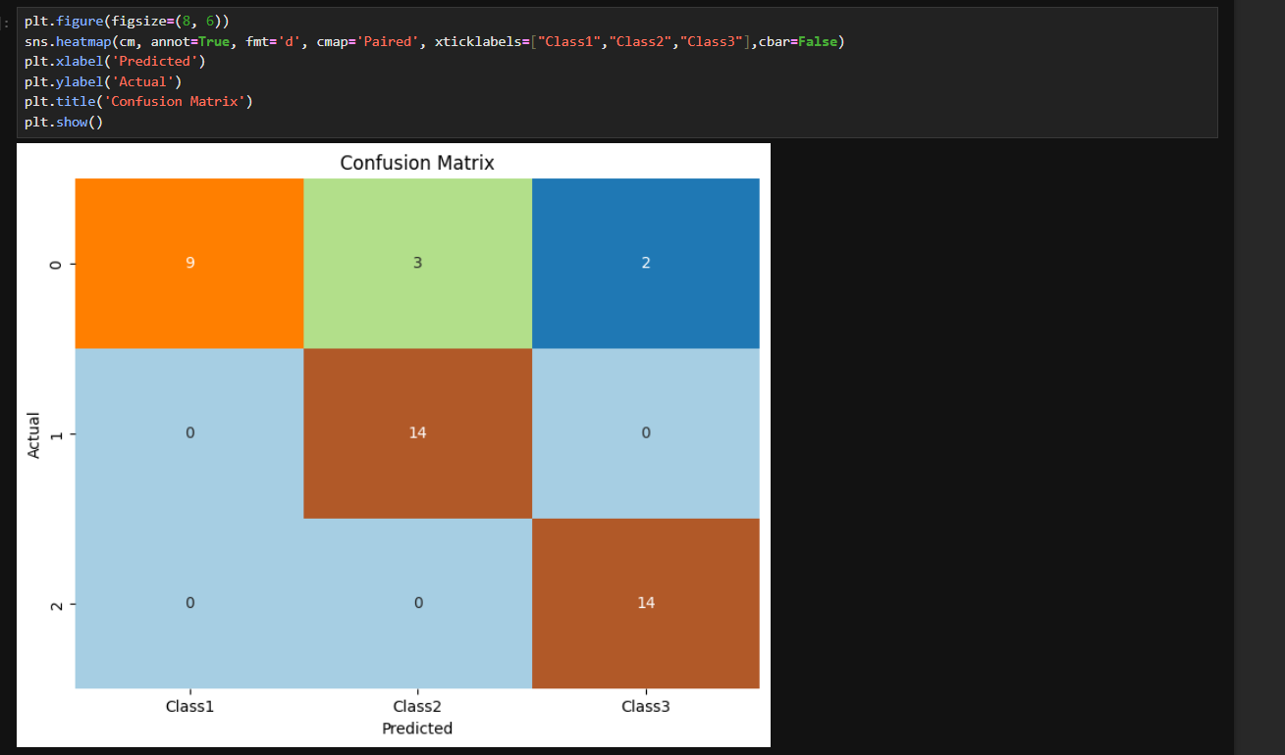this command prints the visual figure for our confusion matrix.

VIVA QUESTIONS
Q1. What does y = y_original - 1 do, and why is it needed?
Ans1: It changes the class labels from 1, 2, 3 to 0, 1, 2. Keras with sparse_categorical_crossentropy expects labels to start from 0.

Q2. Why is scaler.fit_transform() used on X_train but only scaler.transform() on X_test?
Ans: The scaler should learn the mean and standard deviation from the training data only. The test data is then scaled with the same values, so the model never "sees" test data during training.
Q3. Explain this code: Dense(16, activation='relu'), Dense(8, activation='relu'), Dense(3, activation='softmax').
Ans3: The first layer has 16 neurons and the second has 8, both using ReLU to learn patterns. The last layer has 3 neurons (one per class), and softmax turns their outputs into probabilities.
Q4. What is the use of EarlyStopping(monitor='val_loss', patience=10, restore_best_weights=True)?
Ans: It watches the validation loss and stops training if it does not improve for 10 epochs. It also brings back the best weights, which prevents overfitting.
Q5. What does np.argmax(y_prob, axis=1) do?
Ans: The model gives 3 probabilities for each test sample. argmax picks the class with the highest probability as the final prediction.

